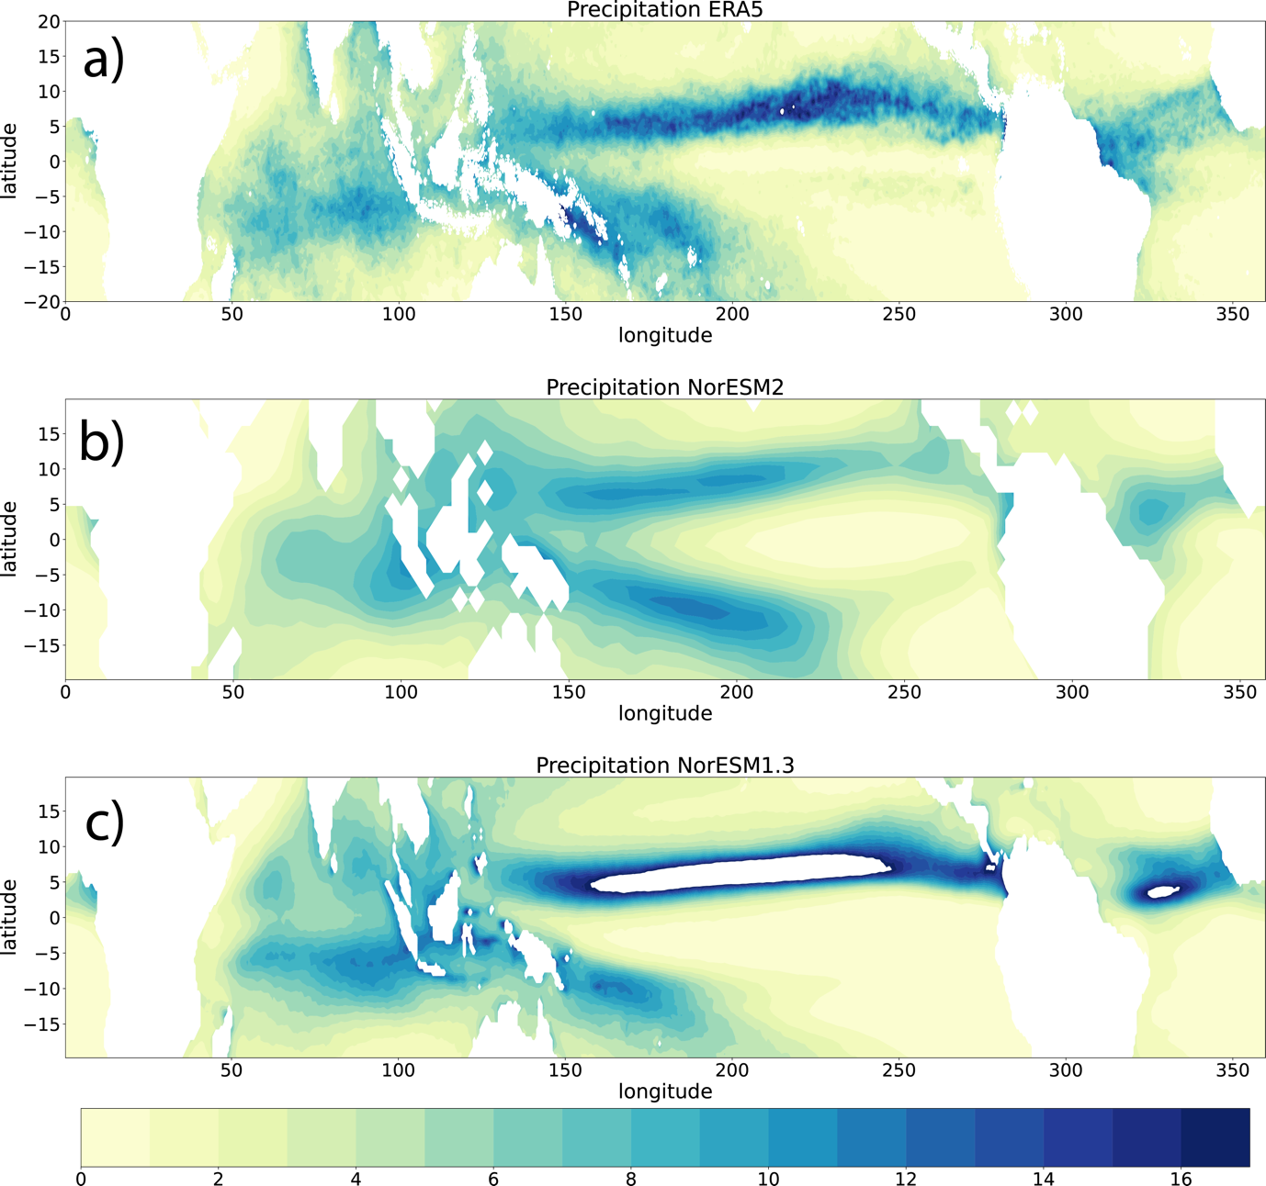

Fig.1 Climate precipitation (mm/day) in ERA5, NorLR and NorSR

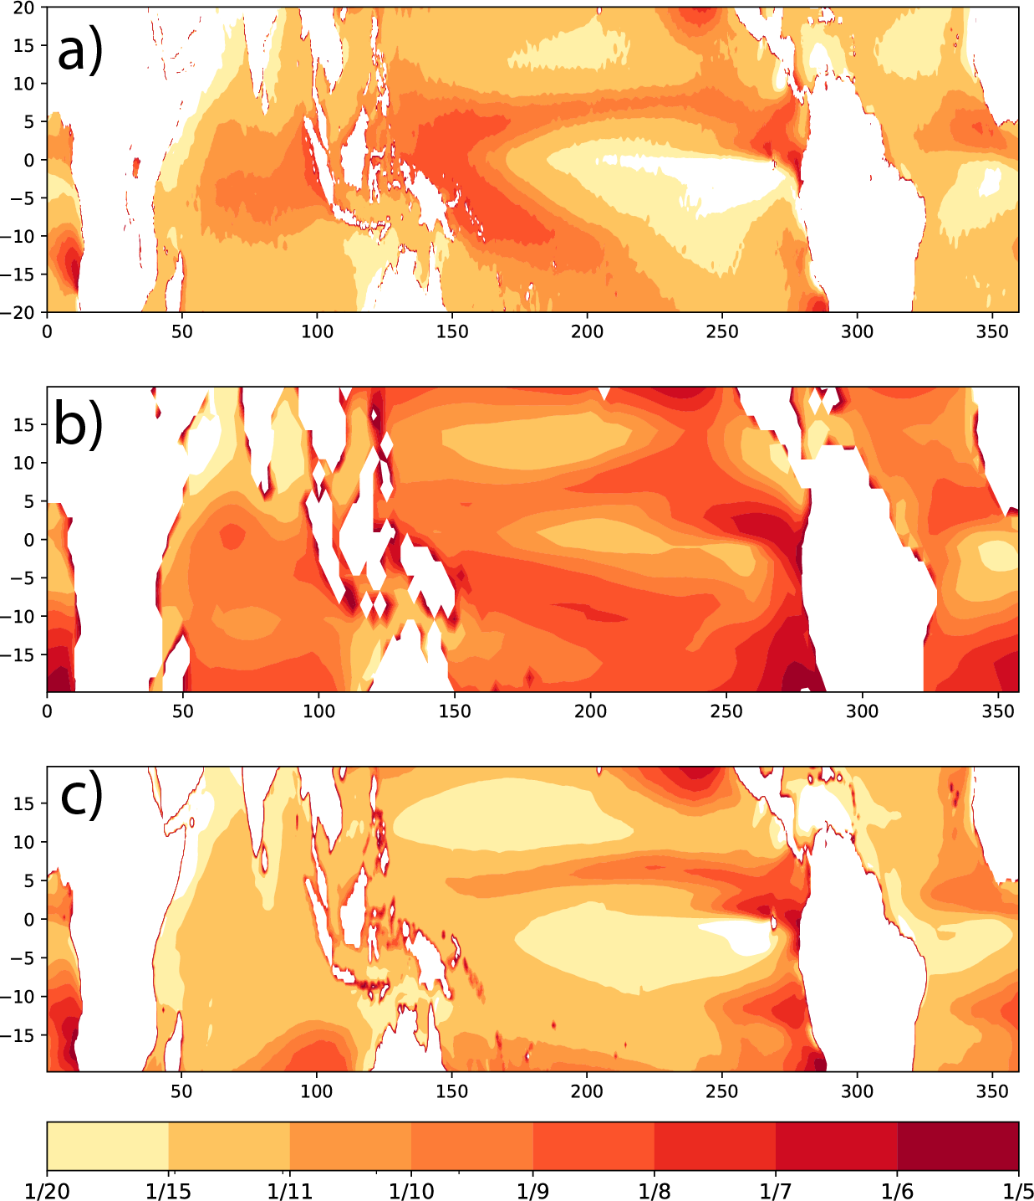

Fig.2 Bowen ratio in the tropical ocean for (a) ERA5, (b) NorESM low resolution version (NELR) and (c) NorESM super high-resolution version (NESR)

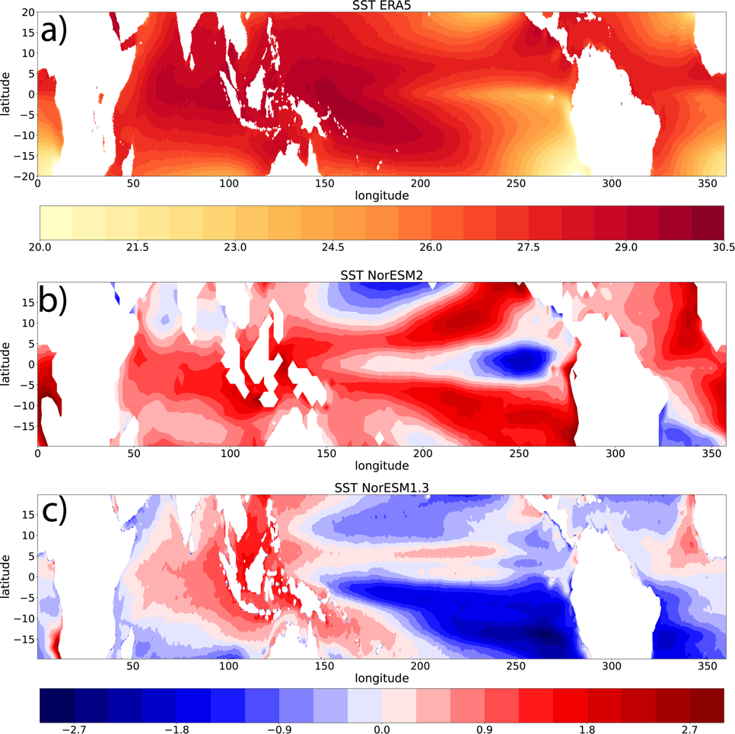

Fig.3 a) SST (°C) in ERA5, (b, c) bias of SST in NorLR and in NorSR

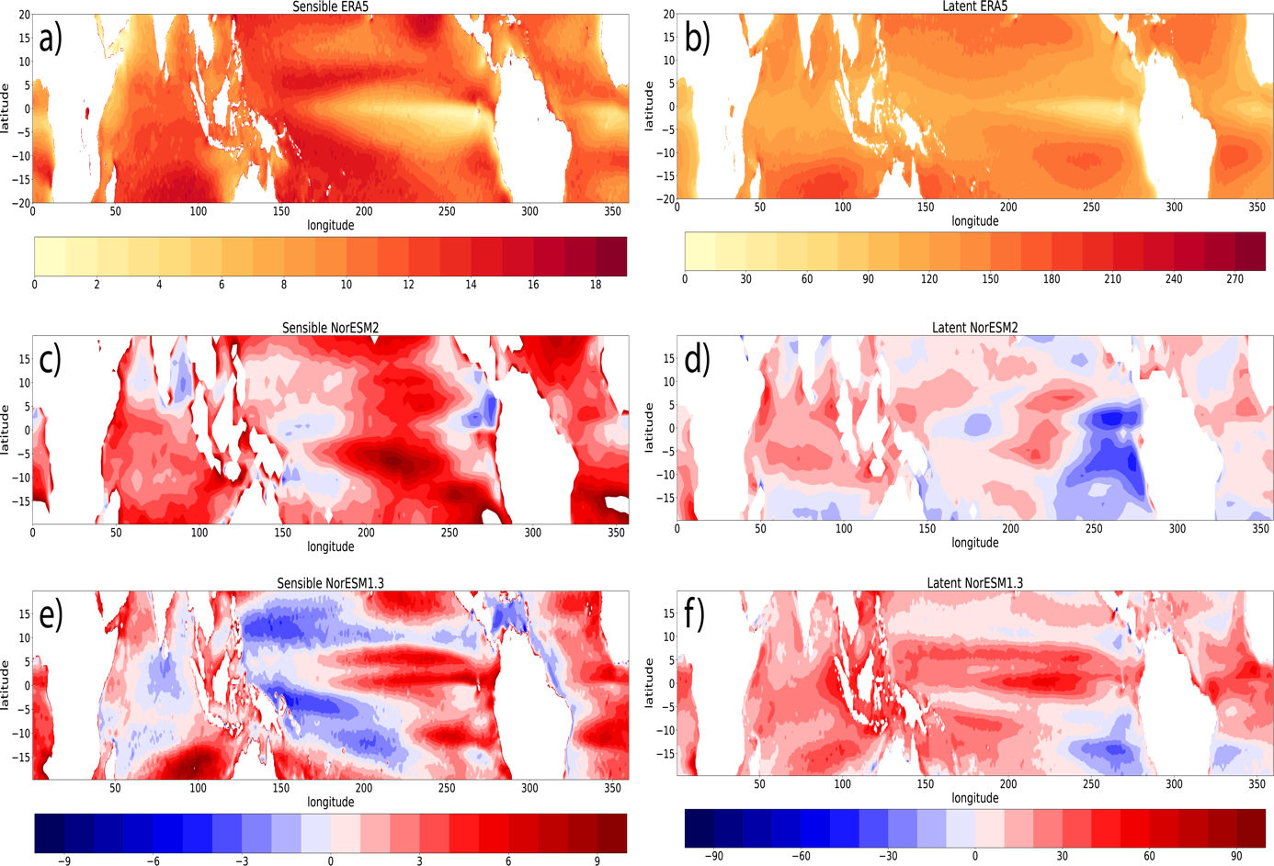

Fig.4 a), b) Sensible and latent heat flux in ERA5, c), d) the bias of sensible and latent heat flux in NorLR and e), f) the bias in NorSR (shall I show the ratio of bias)

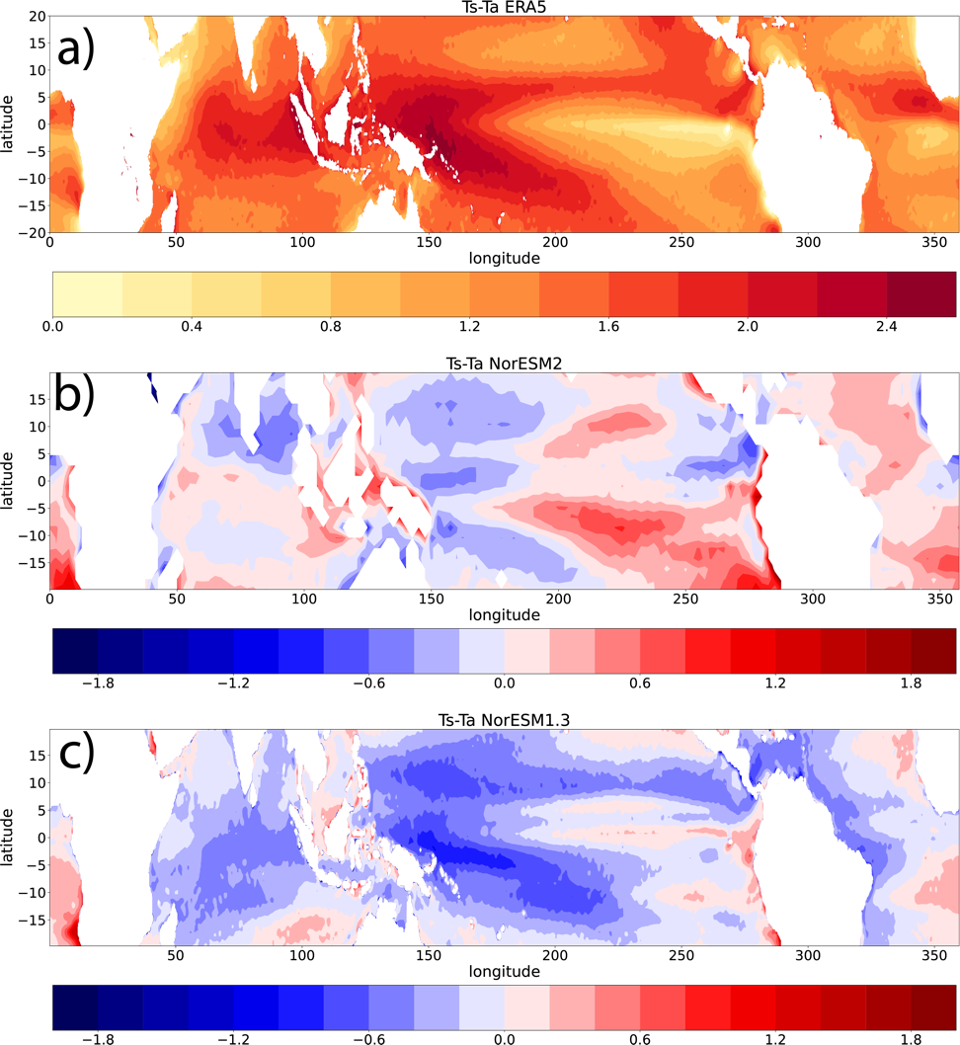

Fig.5 a) Ts-Ta (°C) in ERA5, (b, c) bias of Ts-Ta in NorLR and in NorSR

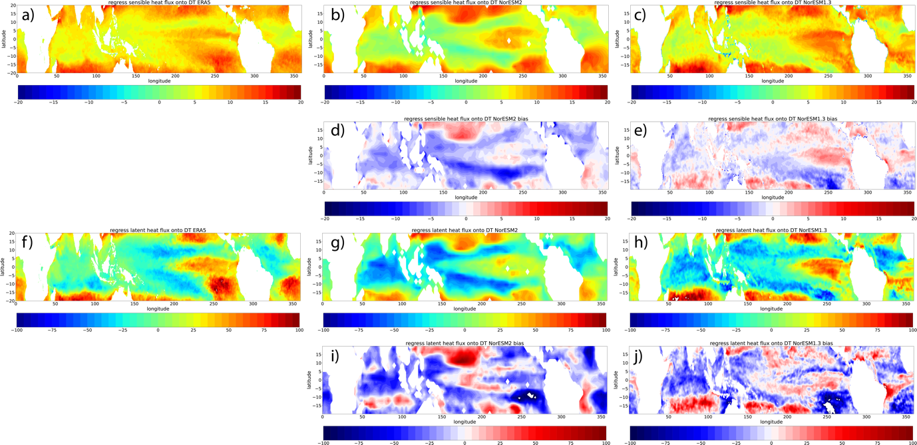

Fig.6 Regression coefficient of daily sensible heat flux to DT (Ts-Tas) in ERA5 (a), NorLR (b) and NorSR (c). d) and e) are the coefficient bias in NorLR and NorSR. f)-j) are similar as a)-e) but for the latent heat flux to DT.

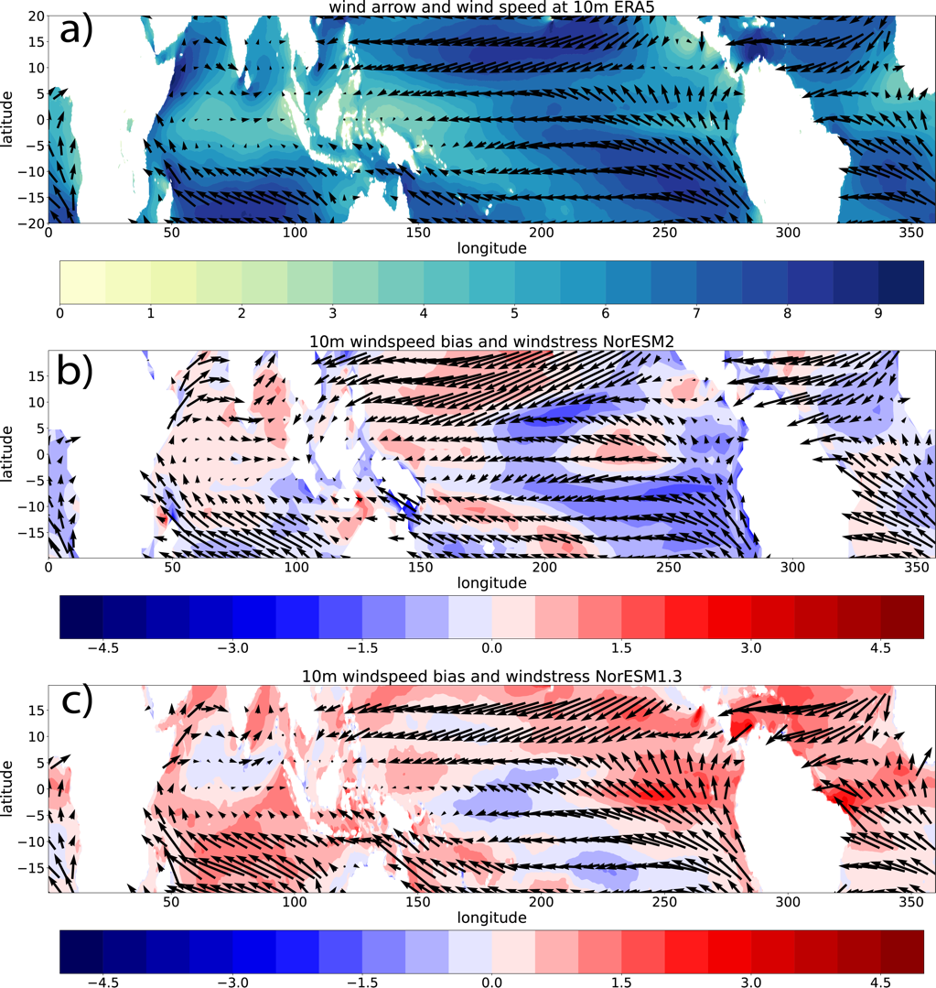

Fig.7 (a) 10m wind speed (shade) and surface wind direction (vectors) in ERA5. (b) bias of 10m wind speed (shade) and surface wind stress (vectors) in NorLR. (c) similar as (b) but for NorSR.

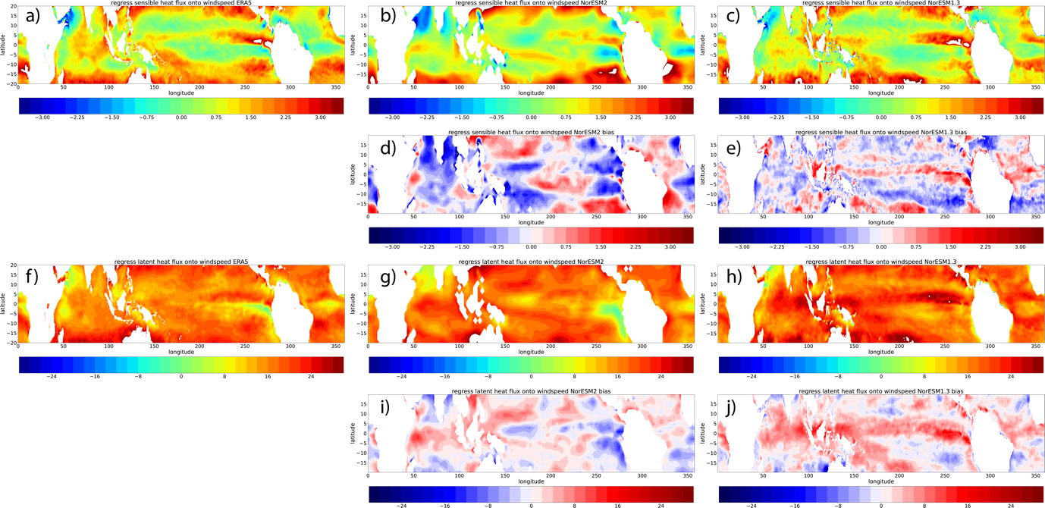

Fig.8 Regression coefficient of daily sensible heat flux to 10m wind speed in ERA5 (a), NorLR (b) and NorSR (c). d) and e) are the coefficient bias in NorLR and NorSR. f)-j) are similar as a)-e) but for the latent heat flux to 10m wind speed.

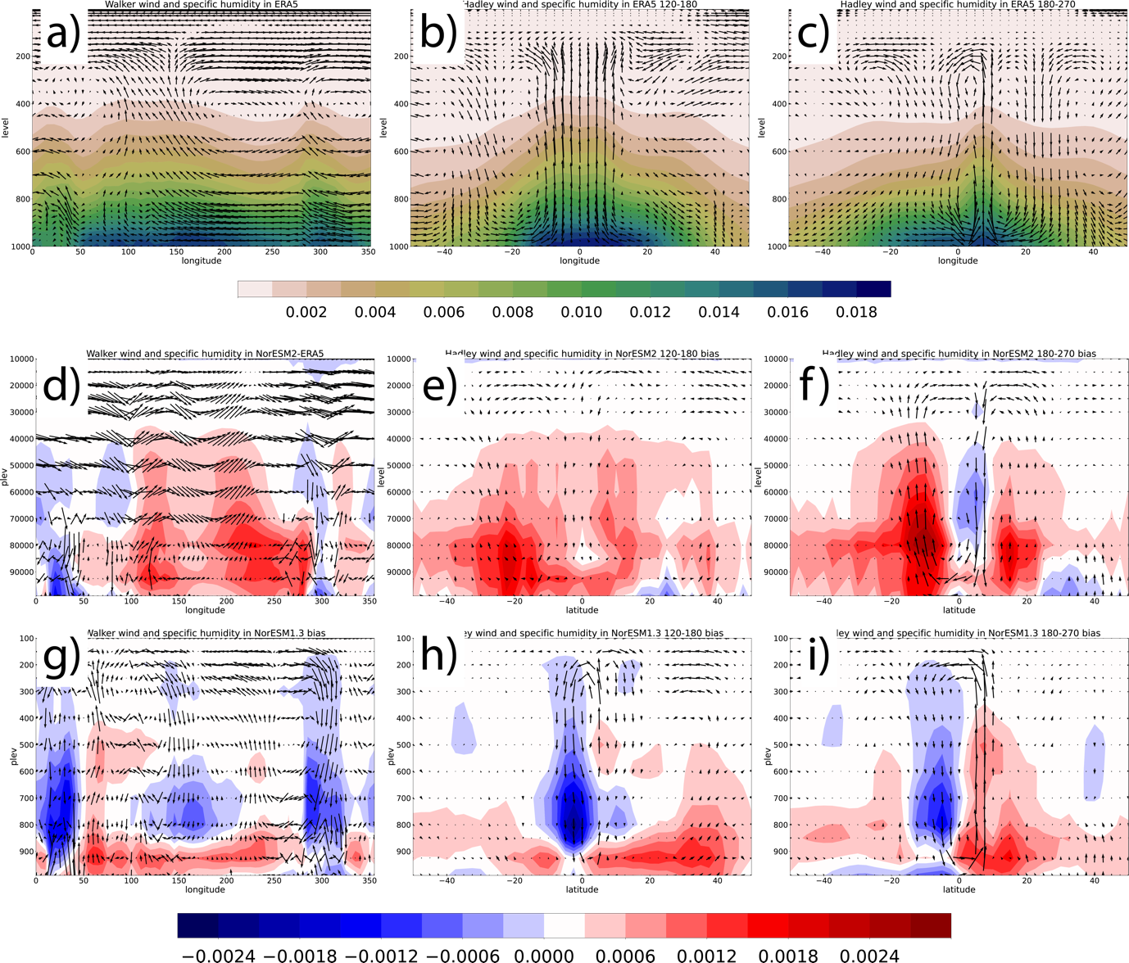

Fig.9 Vectors indicate Walker circulation (a) and Hadley circulation in western pacific (b) and eastern pacific (c) Pacific in ERA5, shade in (a-c) indicate the specific humidity in ERA5. d)-f) the biases of Walker (d) and Hadley circulation in western (e) and eastern (f) Pacific in NorLR related to ERA5. g)-i) same as d)-f) but for model NorSR.

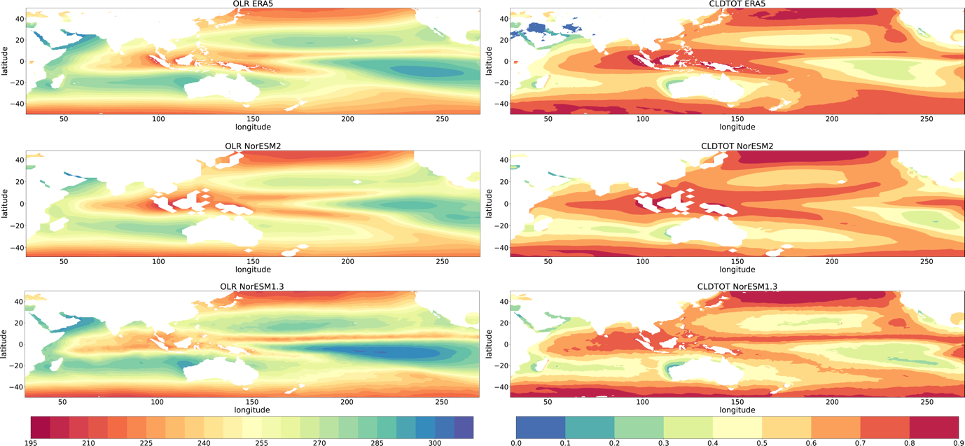

Fig.10 Map of OLR and total cloud cover

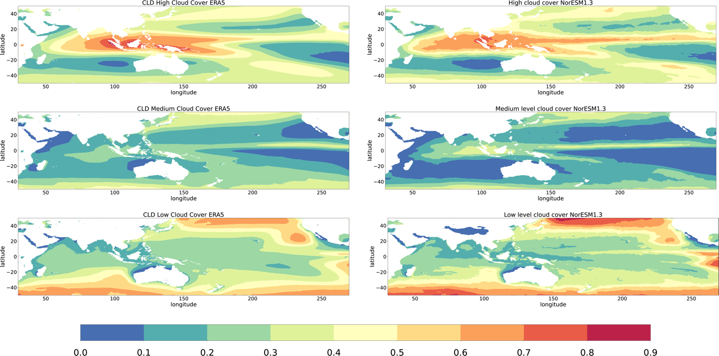

Fig.11 Cloud cover over high level, medium level and low level. High, medium and low-level cloud cover are not shown in NorESM2. Medium cloud:800-400hPa